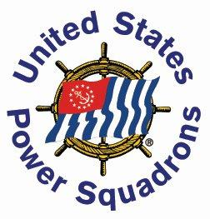
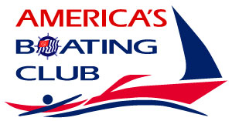
Engine Maintenance
Course

Course overview:
The Engine Maintenance course stresses the diagnosis of modern systems, while also teaching the basics of engine layout and operation. Gasoline inboards, outboards, & diesel engines are taught in a way that reinforces the common aspects of how engines work.

Topics covered:
Older engine & systems; Modern engines & systems, with high reliability & good performance through the use of computerized systems for fuel delivery & engine timing; "Black boxes" that may no longer be serviced by weekend mechanics with ordinary tools; Repairs that do-it-yourselfers can still perform; How to diagnose problems that might be beyond your ability to fix; How to share information with your mechanic so the right repairs get performed.
The course also covers basic mechanical systems such as drive systems (propellers, drive shafts), steering systems, & engine controls. Solutions are discussed that you might use for problems that could occur while afloat & away from a repair facility.
Open discussions welcomed on all related engines & systems.

Register soon. This class is limited to 10 students!!

Date: 8 Tuesday evenings, January 15 through March 5, 2019
Hours: 7:00 to 9:30 pm
Location: Westwood Senior Center/Council on Aging, 60 Nahatan Street
Instructor: Rusty Whitaker, AP
Fee: $95 for members, $135 nonmembers, includes all materials.
Registration: abc-gbh.org/registration
Offered by: Great Blue Hill Sail & Power Squadron, www.abc-gbh.org
More information: Joseph Kelliher abc@abc-gbh.org, 508 668 8149

